VERIFICATION OF GATES

Aim:
To study and verify the truth table of logic gates.

Apparatus Required:
All the basic gates mentioned in the fig.

Procedure:
1.Place the IC on the IC Trainer Kit.
2.Connect VCC and ground to respective pins of IC Trainer Kit.
3.Connect the inputs to the input switches provided in the IC Trainer Kit.
4.Connect the outputs to the switches of O/P LEDs,
5. Apply various combinations of inputs according to the truth table and observe the condition of LEDs.
6. Disconnect output from the LEDs and note down the corresponding multimeter voltage readings for various combinations of inputs.

A | O/P | Y1 (V) | Y2 (V) | Y3 (V) | Y4 (V) | Y5 (V) | Y6  (v)
0 | 1 | 5 | 5 | 5 | 5 | 5 | 5
1 | 0 | 0 | 0 | 0 | 0 | 0 | 0
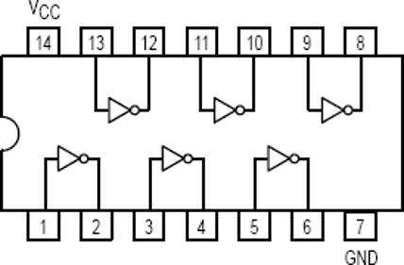
Inverter Gate (NOT Gate) - 7404LS

2-Input AND Gate - 7408LS
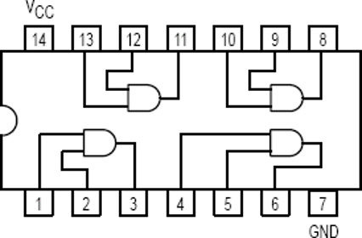

A | B | O/P | Y1 (V) | Y2 (V) | Y3 (V) | Y4 (V)
0 | 0 | 0 | 0 | 0 | 0 | 0
0 | 1 | 0 | 0 | 0 | 0 | 0
1 | 0 | 0 | 0 | 0 | 0 | 0
1 | 1 | 1 | 5 | 5 | 5 | 5

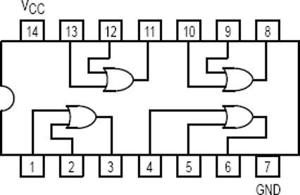

A | B | O/P | Y1 (V) | Y2 (V) | Y3 (V) | Y4 (V)
0 | 0 | 0 | 0 | 0 | 0 | 0

0 | 1 | 0 | 1 | 5 | 5 | 5
1 | 0 | 0 | 1 | 5 | 5 | 5
1 | 1 | 1 | 1 | 5 | 5 | 5

2-Input NAND Gate - 7400LS
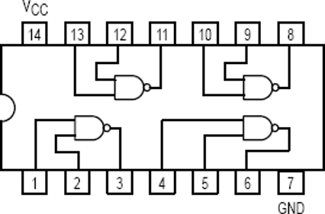

A | B | O/P | Y1 (V) | Y2 (V) | Y3 (V) | Y4 (V)
0 | 0 | 1 | 1 | 5 | 5 | 5
0 | 1 | 0 | 0 | 0 | 0 | 0
1 | 0 | 0 | 0 | 0 | 0 | 0
1 | 1 | 0 | 0 | 0 | 0 | 0

2-Input NOR Gate - 7402LS
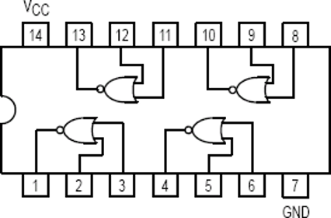

A | B | O/P | Y1 (V) | Y2 (V) | Y3 (V) | Y4 (V)
0 | 0 | 1 | 1 | 5 | 5 | 5
0 | 1 | 0 | 0 | 0 | 0 | 0
1 | 0 | 0 | 0 | 0 | 0 | 0
1 | 1 | 0 | 0 | 0 | 0 | 0

2-Input EX-OR Gate - 7486LS
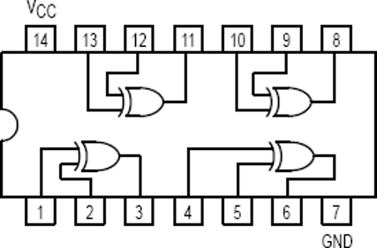

A | B | O/P | Y1 (V) | Y2 (V) | Y3 (V) | Y4 (V)
0 | 0 | 0 | 0 | 0 | 0 | 0
0 | 1 | 1 | 5 | 5 | 5 | 5
1 | 0 | 1 | 5 | 5 | 5 | 5
1 | 1 | 0 | 5 | 5 | 5 | 5

RESULT:
The truth table of all logic gates were sucessfully verified and the observed outputs matched the theoretical value.

